CE101 Team Report Assignment

**Team:** *T*

**Team Leader:**  *Sean Traynor*

**Project Manager:** *Dale Carr*

**Team Specialists:** *Laurynas Pupsta, Charlie Hammond, Valentinas Vaiceliunas*

## Table of Contents

Chapter 1 The Executive Summary (?? words) 3

Chapter 2 Team Working (?? words) 4

2.I An introduction to Team Working 4

2.II Team Activity Report 4

2.II.a The team effort summary table 4

2.II.b Detailed report of each team members contribution to the project 4

Chapter 3 Product Development (?? words) 5

3.I An introduction to Product Development 5

3.II The Team Product 5

3.II.a The product specification 5

3.II.b The product design 5

3.II.c The product implementation 5

3.II.d The product testing 5

3.III Context 5

3.III.a Legal matters 5

3.III.b Ethical matters 5

3.III.c Health & safety matters 5

Chapter 4: Project Management (?? words) 6

4.I An introduction to Project Management 6

4.II Project Management Report 6

4.II.a A description of the Gantt chart 6

4.II.b An evaluation of the project management 6

Chapter 5: Conclusions (?? words) 7

Appendix 8

A. Python Code 8

B Team effort summary table 9

C Project management Gantt chart 10

# Chapter 1 The Executive Summary (319 Words, Sean Traynor)

This is the team report for Team T. In this report every member has written about how the product was developed, what they did to contribute to the product, issues that occurred during and after the development of the product and what the intention behind the product is. The team report is divided into 5 chapters, one of which you have already started reading. When you are finished reading this team report you should have a rather detailed idea of almost every aspect of the development process of the product. The second chapter will inform about team working, some of the difficulties and some of the benefits of working as a team. Chapter two is also where every team member has written a report on their contribution to the product. Chapter three is about the product development, issues that we encountered during and possible issues after the development of the product. The product development chapter is the largest and most detailed chapter in the entire team report. In chapter three you will find the Software Requirements Specification. The SRS is a rather extensive part of this document, as it holds quite a lot of information about the product. In the SRS you will learn who the intended audience for TecInASec is, you can find the scope of TecInASec, definitions and abbreviations used through the entire team report and SRS, and that is only chapter 1 of the SRS. In the end of chapter three is where we explain the legal & ethical issues and also mention some health & safety. Chapter four is the chapter written by the Project Manager, Dale Carr. The chapter will provide you with an understanding of what is involved in project management, and a report on the work that Dale has done as a project manager. To finish the report off we have a conclusion at the end which is counted as chapter 5.

# Chapter 2 Team Working (2060 words)

## 2.I An introduction to Team Working (Sean Traynor)

Working with a team in a collaborative project is a rather challenging process because it requires good communication between several team members, full understanding of tasks that are set and the activities that are expected from each team member. Team working requires that everyone attends to the meetings, and if someone were to be absent; that they make the effort to get up to date on current tasks on their own time.

Working in team can be a lot more efficient than working on your own, although with an inefficient team; there is potential for the team actually reducing productivity. There are more minds working on the same project, all with different opinions on what should be done and how the product will achieve optimal proficiency. This can combine the best pieces of each mind which will eventually result in an improved final product, compared to a project managed and produced by one person.

## 2.II Team Activity Report

### 2.II.a The team effort summary table (Sean Traynor)

In the team effort summary table [Appendix B] we have given the entire team marks based on how much work each team member has done in several different aspects of the product development procedure. As you can see in the table, we were only five persons on the team. There was initially supposed to be six persons, but the sixth student never showed up. In the table we have accumulated points for each team member either on a scale from 1-10, or by rank. The sum of points is simply the total sum of points earned from each column.

### 2.II.b Detailed report of each team members contribution to the project (Sean Traynor, Laurynas Pupsta, Charlie Hammond, Dale Carr, Valentinas Vaiceliunas)

#### Sean Traynor

##### Introduction

I am the Team Leader for Team T. The role of the team leader is to take a part in all the different aspects of the product and process of developing the product, but not fully specialize in one part of the product. A good team leader should also know the skills of each team member in order to fully utilize the team member for the benefit of the product [1]. I think that I was assigned the Team Leader role because of my previous experience with coding, working in teams and because I was generally interested in the responsibility of being a Team Leader.

##### Past Work

I have been posting tasks on the Moodle forum when necessary [2], which have been quite irregularly. The reason for this is because of the good communication that most of the team has outside of the lab sessions. When we first started the group project my first task was to create a team skills list [3]. After that I went on to try out some different graphical libraries for Python, such as Tkinter and PyQt4. The main responsibility outside of keeping updated on what the team is doing and assisting the team in any problems that may occur was the GUI code. I was primarily working on the User Interface for TIAS up until we decided that we should abstain from using Tkinter and create a website instead. [4] We had some difficulties connecting to the database that holds all information that has been scraped from the website because the database is hosted on an OpenShift server. But after some experimenting we figured a simple solution to the problem by using Flask. I have also created a couple of reports and précis, such as a report on Intellectual Property [5]. The day before delivering the product presentation for the lab session we had on Thursday 12th of March 2015, Charlie, Laurynas and I were at the lab working on the website design and making sure that all possible errors that we could think of did not occur.

##### References

[1] – Moodle. “*Week 5 - Laboratory: Building teams*” [www.moodle.essex.ac.uk](http://www.moodle.essex.ac.uk). [Online]. Available: <https://moodle.essex.ac.uk/mod/book/view.php?id=208150&chapterid=1605> [Accessed: Mar. 16. 2015].

[2] – Moodle. "*Team Forum – Team Tasks*," [www.moodle.essex.ac.uk](http://www.moodle.essex.ac.uk). [Online]. Available: <https://moodle.essex.ac.uk/mod/forum/discuss.php?d=98534> [Accessed: Mar. 03. 2015].

[3] – Moodle. “*Reference/Précis and Team Task Database*” [www.moodle.essex.ac.uk](http://www.moodle.essex.ac.uk). [Online]. Available: <https://moodle.essex.ac.uk/mod/data/view.php?d=128&rid=8504> [Accessed: Mar. 15. 2015]

[4] – TecInASec. “*Reference/Précis and Team Task Database*” [www.dbblts.com/tias](http://www.dbblts.com/tias) [Online]. Available: [www.dbblts.com/tias](http://www.dbblts.com/tias) [Accessed: Mar. 15. 2015]

[5] – Moodle. “*Reference/Précis and Team Task Database*” [www.moodle.essex.ac.uk](http://www.moodle.essex.ac.uk). [Online]. Available: <https://moodle.essex.ac.uk/mod/data/view.php?d=128&rid=9606> [Accessed: Mar. 15. 2015]

#### Charlie Hammond

I am the Design Specialist for Team T. It is my job in the team to come up with the ideas, designs and creative inspiration which can be seen in use with our first version of TIAS and my design work will hopefully continue into later enhanced product versions. The design research for the product in this project come not only from my personal prospective but from the rest of the team. It is then my expertise in design to take the collective inspiration from the team and work with them to draft a refined ideas, one that could eventually be implemented into the application/program that we are, as a team have developed.

##### Past Work

10th November 2014 was the start of the teams venture into creating a user-friendly application which will scrape the internet for information about computers and present them in a uniform way with a possible feature to compare the products found with ones saved in our database. It has been my role in the team to collectively work with each of the members, whether it be in the forum chat found online [1] or within a formal or possibly informal team meeting. Since the start of our project timeline I have written many reports covering subjects such as application design [2] to reports on potential health and safety issues the end user may have when operating our product [3]. All of the aspects that I have coved in my reports can be found within the list of uploaded documents our team submits on the Moodle web server supported by the University of Essex [4]. There are features of product design that many clients don’t considered when looking at an application. At this point of the application design, as of the 18th February 2015 my designs are all theoretical works but are essential to the team so that we as a team can collaborate and have an insight to what the final design could be like. Each iteration of the design can be seen in the documents I have uploaded on the Moodle web server. So far the design assets we are interested in using have been uploaded in a folder [5] so that not only I can see and manipulate them, the team also has creative control over my designs to help each of us generate inspiration and influence. In the end it’s hopefully going to be a product that we can all agree on.

##### Additional Notes

At this stage of the design. Astatically the program is plain, clean and simple, we have moved away from using Tkinter as our graphics user medium and have moved to a web based HTML and CSS standard of user infrastructure as we thought that it would make the site more approachable and it means the user wouldn’t have to learn any more then what they do in day to day lives. The colours and the assets on the site are practical and useful over vibrant and attractive. This will be a welcomed change in the future but as of publishing this document application functional features are of more importance. It is then possible for me as a designer to look at the canvas I have and to represent a possible project design that’s not only attractive but logical. The ideas that Team T has for the website are mutual for the teams benefit.

##### References

[1] – Moodle. "*Team Forum”.* [www.moodle.essex.ac.uk](http://www.moodle.essex.ac.uk). [Online]. Available: <https://moodle.essex.ac.uk/mod/forum/view.php?id=208159>. [Accessed: Mar. 15. 2015].

[2] – Moodle. *“Reference/Précis and Team Task Database - Application Design”*. [www.moodle.essex.ac.uk](http://www.moodle.essex.ac.uk) [Online]. Available: <https://moodle.essex.ac.uk/mod/data/view.php?d=128&mode=single> [Accessed: Mar. 15. 2015].

[3] – Moodle. *“Reference/Précis and Team Task Database - Health & Safety”*. [www.moodle.essex.ac.uk](http://www.moodle.essex.ac.uk). [Online]. Available: <https://moodle.essex.ac.uk/mod/data/view.php?d=128&mode=single&page=56> [Accessed: Mar. 15. 2015].

[4] - Moodle. *“Reference/Précis and Team Task Database - Charlie”*. [www.moodle.essex.ac.uk](http://www.moodle.essex.ac.uk). [Online]. Available: <https://moodle.essex.ac.uk/mod/data/view.php?d=128&mode=list&perpage=50&search=&sort=0&order=ASC&advanced=0&filter=1&advanced=1&f_367=&f_368=&u_fn=charlie&u_ln>= [Accessed: Mar. 15. 2015]

[5] - Moodle. *“Reference/Précis and Team Task Database – My work collection”*. [www.moodle.essex.ac.uk](http://www.moodle.essex.ac.uk). [Online]. Available: <https://moodle.essex.ac.uk/mod/data/view.php?d=128&mode=single&page=60> [Accessed: Mar. 15. 2015]

#### Dale Carr

##### Introduction

As the project manager for team T, it is my duty to keep all members updated on the progress of our product. In essence, it is my job to ensure work is being completed on time and to track the progress of our product with a Gantt chart. My duties also include updating the team logbook with the agenda and minutes for each team meeting. While I have not had as much work to complete as others, I believe my work in keeping both the logbook and Gantt chart updated has helped to keep the product on track to completion.

##### Past Work

As per my responsibility as project manager, I have kept both the Gantt chart and team logbook updated with the necessary information. I have completed a report on Tkinter [1] as it was going to be used to create the GUI for our product (decided against at a later date). As the logbook will show, I have not had many tasks to complete, barring the work on the logbook and Gantt chart. I believe this to be due to the higher workload in being the project manager, as well as my other teammates being better suited than me in tasks involving design or coding.

[1] - Moodle. *“Reference/Précis and Team Task Database”*. [www.moodle.essex.ac.uk](http://www.moodle.essex.ac.uk). [Online]. Available: <https://moodle.essex.ac.uk/mod/data/view.php?d=128&rid=9194> [Accessed: Mar. 16. 2015]

#### Valentinas Vaiceliunas

##### Introduction

I am Valentinas Vaiceliunas. I work on a Team T project called TecInASec as a business specialist. I have been mainly working on legal and ethical issues of our team product. My main job was to create a survey and ask other people that may be our customers in the future what kind of things they know about computers and what kind of computer they would look for. My main job tools were Word and SurveyMoney.com website that lets you make and publish surveys.

##### Past Work

At first I had to make a survey so I had to learn how to make and publish surveys, so I did use surveymoney.com and made the statistic work that we got from the survey responses. I have done some other work in the team too, for example some reports for the methods that we used in our programming language, like BeautifulSoup. BeautifulSoup was the main component of scraping and I by doing a research on it I learned how it is used and works on Python programming language. Also I have learned more about surveys, about publishing it and the use of survey making in business because it is very important to know what your customer needs. Working in the T team I learned how every role is important and every person matters in the work they do to the team. I tried to help my team mates if that was necessary but because we have a great team leader who helped everybody and took care of everyone my help was rarely needed. I worked on statistics on our product and I hope I will be working more in the future when our product hits the market. I believe, I could have helped more with programming but I tried to do all the jobs that was given to me as a business specialist.

#### Laurynas Pupsta

##### Introduction

I am Laurynas Pupsta. I am the team programming specialist working a project called TecInASec. I have been mainly working with Openshift server, Python, phpMyAdmin, Flask, git and many more. My main achievements so far are fully functional scraping code for PCWorld, working communication between the server and database and everything associated with gathering and analysing(filtering, manipulating and etc.) information. Template generator and everything associated with the code except for HTML, CSS and JavaScript.

##### Past Work

I have done a lot of work with BeautifulSoup the scraping module for python. Wrote my own scraping code for PCWorld which works perfectly and collects all the information we need. [1] I wrote a report about how easy it is to use BeautifulSoup and how splendid it works in reality and also left a compatible place in the code where you can add more scraping lines for additional information on the computers. I have also been working with python module ‘requests’ which help a lot when it comes to terms of effectiveness. It easier to use HTTP requests than python native ‘urllib’ requests module. [2] I wrote a report about HTTP requests and how a simple code to send a request looks like. I have also been working with phpMyAdmin which helps me work with pymysql module. I can instantly see my stored results from the scraping code and lets me test query codes for storing or extracting information from or to TecInASec database on Openshift server. [3]I wrote a report how useful phpMyAdmin really is and how accessible it is for our every team member. That is why I have also managed to make a site running where team members can actually receive the login details to the database. This makes it easy for everyone to access the database and test queries for the product on phpMyAdmin.[4] Nevertheless, I wrote a report about Flask and why we decided to use it. It is a very powerful Python website template engine and was one of the most crucial elements of our product and could have not been overlooked. As a code specialist I think I managed to deal with my part pretty well. I was never late and never let down my team when it came to the application running.

##### References

[1] – Moodle. " *Reference/Précis and Team Task Database”.* [www.moodle.essex.ac.uk](http://www.moodle.essex.ac.uk). [Online]. Available: <https://moodle.essex.ac.uk/mod/data/view.php?d=128&mode=single&page=29> . [Accessed: Mar. 16. 2015].

[2] – Moodle. " *Reference/Précis and Team Task Database”.* [www.moodle.essex.ac.uk](http://www.moodle.essex.ac.uk). [Online]. Available: <https://moodle.essex.ac.uk/mod/data/view.php?d=128&mode=single&page=30> . [Accessed: Mar. 16. 2015].

[3] – Moodle. " *Reference/Précis and Team Task Database”.* [www.moodle.essex.ac.uk](http://www.moodle.essex.ac.uk). [Online]. Available: <https://moodle.essex.ac.uk/mod/data/view.php?d=128&mode=single&page=58> . [Accessed: Mar. 16. 2015].

[4] – Moodle. " *Reference/Précis and Team Task Database”.* [www.moodle.essex.ac.uk](http://www.moodle.essex.ac.uk). [Online]. Available: <https://moodle.essex.ac.uk/mod/data/view.php?d=128&mode=single&page=62> . [Accessed: Mar. 16. 2015].

# Chapter 3 Product Development (4533 words)

## 3.I An introduction to Product Development (Sean Traynor)

What exactly is product development? As the name suggests, product development is the development of a product and all the processes involved in doing so. There is no correct way of developing a product, as long as the result is a fully functional product. Product development is a rather extensive process and is quite difficult, especially if the product is being developed by several people.

Developing a product usually includes a group of people with a vision for a product, such as a piece of software or technology. It often requires the modification of an already existing product, if this is the case the modification should end up with an improved version of the product, or an alternative version of the product. [1] In our case we are modifying already existing software to best suit our needs. The software we are developing is a price comparison software, but it specialises in computers, specifically for the UK.

The development can be built on a couple of methods. The most common ones are Waterfall and Agile. [2] The Waterfall methodology starts off by determining the requirements and specification. This methodology is commonly used when the developers have a clear vision of how the product is going to work, look like and they know exactly how to get the finished product. This is the reason why the more common methodology nowadays is Agile. Agile is a lot more adaptive and progressive. Agile methodology uses a method called Sprint, and usually lasts for a week to a month. During the Sprint the team members takes on a small set of tasks and generate reports based on what work was done on the project during the Sprint.

[1] - Business Dictionary. “*What is product development? definition and meaning*” <http://www.businessdictionary.com/>. [Online] Available: <http://www.businessdictionary.com/definition/product-development.html> [Accessed: Mar. 03,2015]

[2] - Udemy. “*Agile Vs. Waterfall*” <https://blog.udemy.com> .[Online] Available: <https://blog.udemy.com/agile-vs-waterfall/> [Accessed: Mar. 03,2015]

## 3.II The Team Product

### 3.II.a The product specification (Sean Traynor, Charlie Hammond)

# Introduction

## Purpose (Sean Traynor)

The purpose of the software requirements specification for TecInASec is to inform the intended audience about the plans that we had for the software and what we have done with those plans. The intended audience for the software TecInASec is users that are looking to buy a new computer, and wish to easily search for a name, brand or specify a price range to find the websites that have the best offers on the computers the user is searching for.

## Scope (Sean Traynor)

TecInASec is a computer comparison price application used to search and compare a range of systems by parameters specified by the user. The information about the computers are stored in an SQL database on the online application PHPMyAdmin and is only accessible to the use of the application strictly for security reasons. Using an online server means the information that is stored can be collected from any device with an internet connection. The original idea for the product was a python written application with a GUI add-on called Tkinter. Tkinter is an add-on used for graphic user interface design, the add-on allowed for code to be processed into user friendly visuals by applying order and function to the data collected. After some development with this original concept the team came to a conclusion that this would be used as research for the structure of a final product that will be applied to a web platform by using Flask, JavaScript, HTML and CSS. Queries that retrieve the information get processed by Flask and the content gathered from the queries. This application of our program means we have creative control, allowing the final product to be aesthetically pleasing and the functionality to be sound.

## Definitions, acronyms and abbreviations (Sean Traynor, Charlie Hammond)

**TecInASec**: The name defines the intention behind the software, the cheapest computers found for the user in just a couple of seconds.

**TIAS**: TecInASec, the software name.

**Basic** and **Advanced page**: The two main search pages in the application.

**Results page**: The main page for displaying results to the user.

**Tkinter**: The native GUI library for python we used for developing the GUI before we went over to using website.

**Requests** and **Beautiful Soup**: Libraries used for the scraping process in the python code.

**Assets** and **Elements**: objects in the program that make up the look of the applications.

**HTML:** (HyperText Markup Language) is the markup language that is read by the web browser and displays content to the user.

**CSS:** (Cascading Style Sheet) is the formatting language used to format HTML in a visually appealing way.

**MySQL:** The SQL database we use to hold all of the information scraped from the website we are scraping.

**Flask:** “LAURYNAS FILL IN HERE”

**APPLICATION/PROGRAM:** When we write application or program, we are referring to the python code, Flask code and the HTML/CSS combined into our product: TecInASec.

**Web Server:** We are currently using the URL [www.dbblts.com/tias](http://www.dbblts.com/tias) to redirect people to the OpenShift server as it is a link that is a lot easier to remember than <http://tecinasectemp-pupsta.rhcloud.com/website>.

## References (Sean Traynor)

[1] – TecInASec. “*TecInASec redirect link*” [www.dbblts.com/tias](http://www.dbblts.com/tias) [Online]. Available: [www.dbblts.com/tias](http://www.dbblts.com/tias) [Accessed: Mar. 15. 2015]

## Overview (Charlie Hammond)

This software requirements specification is split into sections. At this point you would have already read the introduction to the document which is made up of a title (introduction) and sub sections labelled in ascending decimal value. This ascending decimal value format can be seen consistently throughout the document with appropriate headings. Section 2 will explain the overall description and will be followed by section 3 which talks about the specific requirements. The following subjects are appendixes and index.

# Overall Description

## Product perspective (Charlie Hammond)

The webpage that presents TecInASec [1] in a graphic user friendly state is just the sector of the product that the public will see. There are many different processes going on in the background that makes the website function in a successful way. The site alone using just HTML would not look or function by any standards near to what it is now. CSS is added to the site to add style and aesthetics which creates a user interface which is pleasing and simple, with this added to the HTML the site would still have no real functionality. Python collects data from sites and then stores this information in an SQL database for use later. From here PHPMyAdmin hosts the site with these modules added to it. Flask then takes the information and processes it for use in the site. All of these modules take collective responsibility over the final product working in a predictable quality of service which is the final webpage.

## Product functions (Charlie Hammond)

There are a few functions that go on in the background of the TIAS site which the user doesn’t see; and with good reason. This is not what the user needs to see and think about, the point we as are team are trying to make is that the system of control we use means that the user doesn’t need to really learn what they already know; and with websites becoming the main hub of information we try to stay true to this way of data gathering and keep the user from having to learn any complicated programs or languages to use our product. All this hard logistics is hidden and dealt with by our specialist team. From the data gathering with Python programs scraping websites for information to presenting the results when the user pushes the search button.

Step by step here is a breakdown of what happens behind the website.

1st) The python program refreshes database with content retrieved from the scraping code every 12 hours.

2nd) The information collected is then stored in a SQL database online for extraction and use on the site later, this information is sorted and filtered out to store only the name, description, price and link for each individual product.

3rd) The parameters of a user’s search are grabbed from the site and then looked at in SQL which then sorts out the data needed to be presented in the results webpage. By doing this a new table of information is created before the next process is made.

3rd) The Flask goes through the information in the SQL database and looks at the order of the new table created using the search query and then the information is grabbed by Flask and with each loop it collects line by line the name, price, description as well as the link from which the product is located and is then sent to HTML as mark-up language.

4th) CSS is then added to the results which makes it formatted to a theme or design specified by the CSS file located separately from the HTML files.

5th) The results are shown on the screen in the webpage in a formatted ordered user friendly manner ready to be inspected with mouse clicks and tab functions allow the user to open each product without losing the current website.

## 2.3 User characteristics (Sean Traynor, Charlie Hammond)

TIAS is made to be as simple as possible to use, there is no need for any extensive technical knowledge, nor experience to use this type of product. The optimal user group would be users that have had some previous experience with using entry fields to fill in information, and users that understand that the software isn’t written by professionals. A point to be made is that errors can occur at any time if the user were to input something that we did not take into account whilst developing the software.

Future implementation has been looked into for the more computer savvy, giving them more of an experience from the website. As it stands now the site has one advanced, inactive function which we hope to develop in later iterations of the site and with each iteration we hope to bring our vision that the public user from novice to advanced can be welcome to the product and hopefully use it to its greatest capability.

## 2.4 Constraints (Sean Traynor)

As we are using a website for user interaction with the software, there are not really many constraints. Hence the adaptability of websites, we can view the product on almost all devices that can connect to websites, such as tablets, cell phones, computers and several other devices. Due to the extensive variety of web-browsers that exist across the different devices, there are some constraints that occur when it comes to displaying things identically across the different browsers. If one were to access the website on Internet Explorer, it would display with either more or less margins around some elements than it would display on Google Chrome and Firefox. There aren’t really any constraints when it comes to hardware for the user, as websites are quite processor friendly. Two of the major possible constraints are heavy web-traffic and security. Since we are hosting the website on a free service called OpenShift, we haven’t really got much control over how much traffic the website can hold before the servers are overloaded, and as we are hosting the website on OpenShift servers, we haven’t really got much control over the security measures that are being used for our website.

## 2.5 Assumptions and dependencies (Charlie Hammond)

There are very few dependencies and assumptions with our product, as we use an online server and host the webpage most of the technical side of the product can be seen and managed away from any public users end device. Although our efforts to make this product effort free there are still some dependencies that cannot be completely removed. One of which is that with it being an online server and the information comes from online resources the user would have to have a basic mobile or home internet connection. Another would be that depending on the type of security the end user has could ask interfere with the use of the product. We assume that the majority of the users have most of the basics to get them online and we also assume that they are not very technical people, that’s why we make the site so simple. We also assume that the user has a device capable of looking at the internet and has at least the screen applicable to seeing the site in a good resolution and size.

## 2.6 Apportioning of requirements (Sean Traynor)

When this document was written the version of the website is 1.0, so we have quite a lot of features that are planned for the product which will implicate a couple of other dependencies. We have been debating a mobile application for the product, and we have also been debating implementing device specific layouts for the website. Other versions of the product may contain added functionality such as comparison between products, more specific search possibilities such as specific hardware components, limiting the search to specific websites, adding user comments from the websites that we retrieve computers from and recreating the website in an application such as Macaw [1] to create a website that is displayed in the same way on almost all browsers.

[1] – Macaw. “*Macaw website*”, [www.macaw.co](http://www.macaw.co). [Online]. Available: [www.macaw.co](http://www.macaw.co). [Accessed: Mar. 16. 2015]

# Specific requirements (Sean Traynor)

There is a lot of different ways to access our product since it is accessible to any device with an internet connection. External interface requirements are at least a device that can access websites, internet access and a screen to display the content from the website. Upon the delivery of this report the product is able to generate content into an online accessible database which is only accessible outside of the website by a person that holds the host IP, username, password, port and database name of the server that holds the database. When the user has satisfied the different requirements and accessed the website, the user will be able to very easily generate a search query that retrieves computers based on what the user inputs. If the user were to hit the search button without entering any information into the search fields; he is presented with every entry in the database. If the user were to enter a search into the search field; the user is presented with results that satisfy the content that is provided to the query. When searching for a computer, the user has two choices to make in version 1.0: Providing us with a simple search entry or using the price range feature in accompany with the advanced features when they get added in future versions of the website. The reason for this is to counter users trying to find computers and removing results because the computers in the database don’t conform to the query generated by the user. In version 1.0 the users will not be able to create any accounts because of the current lack of features implemented to the product. There are some non-functional requirements that come along with hosting an online service. The obvious requirement is a network connection, but there are quite a lot of other requirements. Since we are using the free service OpenShift to host our website, they cannot guarantee uptime, nor can they guarantee how much traffic the servers can handle. This leads to unclear capacity, response time and fault recovery time. Based on prior experience and online reviews of OpenShift we are quite confident that the uptime of the website will be quite decent.

# Appendixes

# Index

1. Introduction
   1. Purpose
   2. Scope
   3. Definitions, acronyms and abbrevations.
   4. References
   5. Overview
2. Overall Description
   1. Product perspective
   2. Product functions
   3. User characteristics
   4. Constraints
   5. Assumptions and dependencies
   6. Apportioning of requirements
3. Specific Requirements
4. Appendixes
5. Index

### 3.II.b The product design (Sean Traynor, Charlie Hammond)

The design of the product is set to be as user friendly as possible. The reasoning behind this is because we want the target market to feel at ease with the software at first glance. All of the elements on the GUI are optional; as long as at least one of the fields is filled in the user will get a result. The thought behind this idea is that users might only want to search for a specific price range, or users might only want to search for a specific brand regardless of price.

The appearance of the application is a likeness to the simple practical aspects of the program. The established iteration of the product is not too simple where as it would be boring and bleak but again not too vibrant and distracting thus to keep the user from detracting the attention away from the intentions of the application. The design process of the application follows some simple steps. Ideas, refinements, discussions and implement; these rules help to guide the ideas into satisfied implemented graphics or assets. From the step by step process it's been possible to implement one of the team’s most significant assets, the logo. Shades of black and red in the colour palette work well with each other, this coloured theme has become the signature for the application. With each step in the design process all the assets and graphics seen in the application follow the same theme to keep it professionally consistent, aspect like this in the product design aid to insure top quality production for the users benefit.

Product design also holds some legal matters which will be explained in depth in section 3.III.a of this document.

### 3.II.c The product implementation (Laurynas Pupsta)

### Everything started from simple design sketches and only the idea how to implement it with python. We experimented a lot with the different programming environments and libraries we decided to try out, and after a lot of testing we initially decided on using Tkinter for design, which was later removed from the product and replaced with a website. The programming has always been consistent with Python modules such as BeautifulSoup, Requests and later we decided on using Flask and its components as a python substitute for the alternative server-side language PHP.

### The very first goal was to create a simple application on Openshift server (that works with python 3.x language) that could be the base for the code, database and the GUI. The first thing we implemented was the main WSGI application on which Python code basically runs. We also included MySQL 5.5 database to the app in which we would store all the information gathered. Nevertheless, we made a simple template for the code where when and how it would run. We also implemented phpMyAdmin so we can manage, check and test queries with our database. This is the most flexible way to do it. Our team achieved everything that we planned on this stage. The python base template stayed practically the same in the whole time spent of the project. The database is working fine on Openshifts and phpMyAdmin is still the best way to monitor our database.

### The second aim was to create a simple scraping code to gather information from the site ‘PCWORLD’. Our intention was to gather laptop computer names, prices, descriptions, picture URLs and links. For this task we used Python REGEX (re) module, BeautifulSoup and Requests. It was fairly easy using all these tools perhaps because all of them can be combined together in a manageable way. You can clearly see in [appendix a.7] that the scraping code is not long at all. This just proves that the 3 tools that we use are very efficient. Nevertheless, you can also see in the image that we use python regex for finding patterns, in other words, specific words, keywords or numbers in a String. So far, we managed to finish the tasks on the second goal. However, there is still a lot of space for improvement.

### The next task was to store the information we gathered into a database. We chose to use PyMySQL module (pure python mysql drivers) to connect to our database on Openshift server. We also had to use Query Language for storing the information. The hardest part in stage 3 was to actually connect to the database. We required information, such as ‘HOST IP’, ‘USERNAME’ and ‘PASSWORD’ to make it happen. In appendix a.6 you can see that that the code has some aspects from python, and also some of the typical aspects from SQL as well. Another difficulty we faced was getting used to PyMySQL syntax and way of working with the database. After long hours of researching and hardworking we managed to get it working.

Our next objective was to create a website using the Flask website template framework. Coding with HTML, CSS and JavaScript went really fluently. We did not engage any major problems while working on a simple HTML template. After that we had to insert python language inside a webpage. Our team decided to use Flask for this part of the objective. As mentioned, Flask is one of the most powerful web development frameworks for Python and at the same time, fairly easy to use and understand. We started from basics, adding bit by bit. We thought that the website will not require any complex queries or coding lines as indicated in [appendix a.13] but we were wrong. Instead of a simple loop we had to implement a lot of ‘if’ statements to keep track of what the user is doings as shown in [appendix a.9]. Just before finishing the template with python we started pulling out information from the database with ‘query language’. This part was a relief because everything seemed to work rather fine on the first tries. After we were done the code looked like in [appendix a.4] and [appendix a.5] .By the time queries, Flask and web design were done we finished stage 4.

The last stage was to finalize everything. This was basically the part where we discussed everything that we have done and things that we could still do in the near future. The idea was to inspect all of the stages of the project and thoroughly analyse them. We concluded that our product was well designed (there is always room for improvement though). Compatibility was achieved because the only browser that does not display our product correctly is Mozilla Firefox. Nevertheless, performance was a great deal. Our product can load and get the result page with hundreds of computers ready in seconds. However, there are quite a lot of features we have not implemented yet. We should have made a comparison function but it would have taken a lot of time and effort with all those different specifications of computers. This would be the main thing to implement in the future. Design could also be improved so that it would not distract. Overall, the main phase of the product was done and all of our team members are satisfied with the result.

### 3.II.d The product testing (Sean Traynor)

The method we used for testing the product was ad-hoc, the reason for this was because we had a limited knowledge of how the libraries we were using worked, and how well they could be connected together to form the product. This was mainly just problems that we encountered before we changed from using Tkinter to using a web server to host a website. After that, most of the testing became quite simple because everyone had access to the website once it was uploaded to the server. Once we had fully released version 1.0, we quickly went through the most common errors that could occur such as a mistype into the fields and found that most of the different search queries would generate the correct response on the website. After we had tested the product we allowed some friends to access the website and test it out, most of them also came back with the same response: that there were minimal errors and they were quite confident with how the product worked.

## 3.III Context

### 3.III.a Legal matters(Charlie Hammond, Valentinas Vaiceliunas)

The design stage of the product can have some complicated legal matters which can affect the product throughout the development and after the working release. Image, text and likeness of other products are the main issues that lead to a legal matter which our university student team cannot contend with. This could be the use of a font, like the “T” in the logo to the general presentation of the application itself. If any large company seeks to file any legal action towards our developing team; as a team we would need to come to an arrangement which would take time, time better used creating a stable, professional product. One of the most important issue is the legal matters. There are many things that the product developers should do. Every software that companies or developers do has its own copyright, however to make the product people use other software. Our team used Python for the programming and this is a free developing tool that you can use and sell any product you make with it. However , some software are not free , so in order to use them we have to buy them that we could use the software to develop and put our product into the market. A copyright is a big deal in the legalization of the product. Our team has all copyrights of the software we used to develop our product and that means we have no problems using it and putting it into the market. If we would use any software that our team has no copyright of and put it into market, we would be responsible for the illegal action and there would be consequences, for example a lawsuit filed on our team. We are fully aware of it and in order to establish a good reputation of our product we use only the developing software that is legal to use for our team.

### 3.III.b Ethical matters (Valentinas Vaiceliunas)

Making a product, one of the main thing to consider is the ethical behaviour, because this leads to the success of the product. Our priority stands for assuring that the highest legal standards are observed in the relationships with the people we work. The most important person in business is the customer. Losing a customer means losing money and losing reputation in business. While the customer is the most important person the product must serve him right and the customer must be treated by the developers with all the respect, that includes no lying, no problems in using the product and if there are some issues than solving it as fast as possible. The people using the product must get the best of it without any issues and must be treated with respect because they are paying money for the product. In order to make that happen we must insure that our product goes into the market fully ready and well tested and if there is something wrong with the product people must be insured that they can get a refund ,for particular reasons, that may occur if the customer has paid money for it. Also, it is very important that the developers create good working environment and that the new developers would be welcomed to the team nicely and would get along. These are the main ethical features for the product that our team has.

### 3.III.c Health & safety matters (Dale Carr)(218 words)

With regards to health and safety matters, our product is a very low-risk program. It does not require much input from the user by keyboard or mouse (thus lowering the risk of RSI while using the product). The website we have created also uses no flashing colours. Avoiding photosensitive epilepsy triggers in our design lead to the use of the grey-to-red fade on the items, Rather than have it instantly transition from one colour to another [1].

Our simple grey, red and white colour scheme provides a good, high-contrast website that should be suitable for use by anyone with a colour receptive deficiency. For future development, however, we should have some tests done to determine the exact suitability, and possibly implement a colour vision defect-friendly version [2].

While also having a good contrast for those with sight disorders, we have also taken steps to prevent them. Specifically, our website does not have a harsh background or colour scheme, both of which help to reduce the effects of eye-strain on the user.

While steps have been taken to reduce the effect of some possible health concerns, there are still those which are just caused by the use of a computer. RSI and computer-related stress [3] disorders are still a concern which we will try to address in the future.

[1] Epilepsy. "*Photosensitive epilepsy*" [www.epilepsy.org.uk](http://www.epilepsy.org.uk) [Online]. Available: <https://www.epilepsy.org.uk/info/photosensitive-epilepsy/triggers> [Accessed: Mar. 16, 2015].

[2] IET. “*Colour Defects*” [www.theiet.org](http://www.theiet.org) [Online]. Available: <http://www.theiet.org/factfiles/health/colourdefects-page.cfm> [Accessed: Mar. 16, 2015].

[3] Stress Relief Choices. “*Computer Stress*” [www.stress-relief-choices.com](http://www.stress-relief-choices.com) [Online] Available: <http://www.stress-relief-choices.com/computer-stress.html> [Accessed: Mar. 16, 2015]

# Chapter 4: Project Management (1038 words)(Dale Carr)

## 4.I An introduction to Project Management(437 words)

A project is defined as a series of interconnecting, sequential tasks that all lead to a specific goal [1]. It is the role of the project manager to maintain an overview of these tasks and keep the project headed in the correct direction [2].

* *Size/cost: investment of money and people*
* *Importance: mission critical*
* *Duration: critical time window*
* *Complexity: across Departments, organisations, countries*
* *Technology: is it off the shelf or breaking new ground?*
* *Risk: what if? (more on this later in the chapter)*

The importance of planning in a project management environment cannot be overemphasised. Careful planning allows for the project to move as smoothly as possible without encountering any avoidable pitfalls. While planning allows for much more control over the project, there may still be times in which unforeseen circumstances can arise. Risks are these unforeseen events that change the course of a project (be it positively, or negatively). For the sake of maintaining stability, it is very important that the risk is dealt with and the plans altered to accommodate it accordingly.

With our product, our team implemented the agile methodology with regards to project management. This meant that our product development was split into many small pieces (iterations) [3], each of these being reviewed before moving on. As we had to make quick decisions with regards to the final direction and production of our project, using agile methodology was definitely the correct path for us. To be more specific, I believe the scrum method was the closest comparison to how we approached project management. The scrum methodology involves splitting the work into what needs to be done in a particular timeframe [5]. While some of our time frames have been quite variable, this has been the best way for our team to work.

Project management tools

As with any other team member, the project manager has several tools that can be used to ensure his job is as manageable as it can be. The first of such tools is the Gantt chart, this chart allows the project manager to create tasks, allocate resources and accurately calculate the hours put in to the project (The Gantt chart can be seen later in this document).

As well as the Gantt chart that we were advised to use, we also created a repository on GitHub for this document. Using GitHub allowed us to track the progress of the team report as well as being able to view all of the changes that each of us have made. This was a very useful tool for project management as it allowed me to see exactly when each part had been updated [4].

[1] Wysocki, Robert K, “What is a project?” in Effective Project Management: Traditional, Agile, Extreme, 7th ed. John Wiley & Sons, Incorporated, 2013, ch. 1, sec. 3, page 1, lines 1–6.

[2] List taken from the online module book.

[3] Jeffrey A. Livermore, “Factors that Impact Implementing an Agile Software Development Methodology”, Walsh College, page 1, Section 2.

[4] <https://github.com/dbblTS/TecInASec_Reports>

[5] Roy Morien, “Agile Management and the Toyota Way for Software Project Management”, 2005, Centre for Extended Enterprise and Business Intelligence, Curtin University of Technology, Perth, Australia, page 520, Section IX, “IN THE SCRUM - SOME FEATURES OF AN AGILE METHOD”.

## 4.II Project Management Report

### 4.II.a A description of the Gantt chart(248 words)[1]

In order to help keep track of our progress as a team, we created our Gantt chart. It shows each task from when it was assigned to when it was completed. As you can see, the first task was assigned of the fourteenth of January; this is a few weeks after we were given the document to use. This time discrepancy was due to a misunderstanding of how to use the Gantt chart itself. Our first chart was simply detailing the macro aspects of the project and was extremely vague. Ultimately, it was dropped in favour of a more micro-level chart, detailing each task, no matter how small.

Our Gantt chart has had to be modified in certain cases, especially where deadlines were moved forward, other succeeding tasks had to be rescaled or moved around in order to ensure the main deadlines were reached at the appropriate time.

As can be seen towards the end of the charts lifespan, many tasks were given a comparatively small timeframe in order to be completed; this was due to the encroaching presentation date in which we had to show our finished project. This was a final sprint to ensure that our product was finished on time.

Overall, I believe that the Gantt chart did help give us an idea of where we were heading, except for the final sprint. If we had planned more carefully, we could have avoided having such a large workload in such a small amount of time.

### 4.II.b An evaluation of the project management(353 words)

Effective project management requires careful planning, adaptive strategies and good risk assessment. By this definition, I believe that we have employed good project management within our team. We have kept up to date with all given assignments and have successfully completed our product within the given date. Our product was placed seventh in the top 10 most likely to be bought [1].

While overall, we have implemented good project management, we have had some minor hiccups. One of the main examples of this would be our sprint towards the end of product development. This was due to late change in our method of finalising the product. We found that some of the ideas that we had were not compatible with the software we were using so we had to scrap what we had and change to a more suitable software. This put a large dent in our plans and we had to reshuffle some task in order to get back up to speed. With greater planning we would have noticed that the software was not suited to our needs.

We found that many of our original plans were not compatible with our later ideas, including the actual format of our product. The original plan was to have it as a downloadable program, but for aesthetic and compatibility reasons, we transitioned to using a website.

As far as tracking our progress, we definitely succeeded. All team logbook entries were kept up to date as well as the Gantt chart. Project management for our team has been extremely malleable, we have had so many changes to our original plan, it was very important that I, as project manager had continually changed the management style in order to keep up with the dynamic nature of our product.

In the future; with regards to project management, our team should take a much more in-depth approach to planning. Had we researched fully what we were using, we would have avoided having to change some of our approaches and software later on. Ensuring all software is fully checked for compatibility would be a great help to the development stage.

[1] CE101 Project Presentation Results.docx, as emailed to all students Fri 13/03/2015.

# Chapter 5: Conclusions (Charlie Hammond, 398 Words)

In conclusion, this document highlights how as a team we have come together to complete a project with work based evidence and a functional product produced by the members of Team T. Every member has contributed their time and collective knowledge to the product throughout the development process. What they did to contribute to the product has been published in their own words and references to sources can be found in this document where evidence can be collected and inspected for validity. As a collective any issues that occurred during the development of the product have been dealt with in a professional manner and any legal matters; respected by every member. These 4 past chapters have hopefully guided the intended audience throughout our team’s development process with clarity, as stated in our introduction we hope that we have given a rather detailed impression of almost every aspect of the development process while creating TecInASec. This product wouldn’t be possible without the contribution of every team member and in chapter two we optimistically hope that anyone can see our vision. If any misunderstanding where to come apparent then we encourage you to reanalyse the third chapter which is the product development chapter, as this is the largest and most detailed chapter in the entire report. It contains the Software Requirements Specification (SRS), a rather extensive part of this document it describes the product in great detail.

Working with a five man team in such an intellectually creative collaborative project has been a challenging and insightful process, requiring good communication and self-evaluation from every team member. With the members of our team pre-selected we quickly found that each member has a vastly different interpretation of what is expected from the team. We have worked in a more efficient way by electing each person to be dedicated to a specific job, this can be seen in the team activity reports each member has included in this document. There is also a team effort summary table at the bottom of this document braking down each member’s contribution to the project and highlights just where each person has specialised throughout the development process.

Finally we anticipate that you have taken some perception to our ambitious work and have occupy yourself with our product and we hope that you can appreciate each member with their future ambitions with this project and many others that.

# Appendix

## A. Python Code

[1]

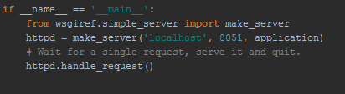

[2]

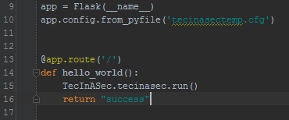

[3]

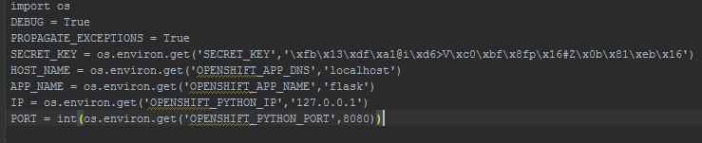

[4]

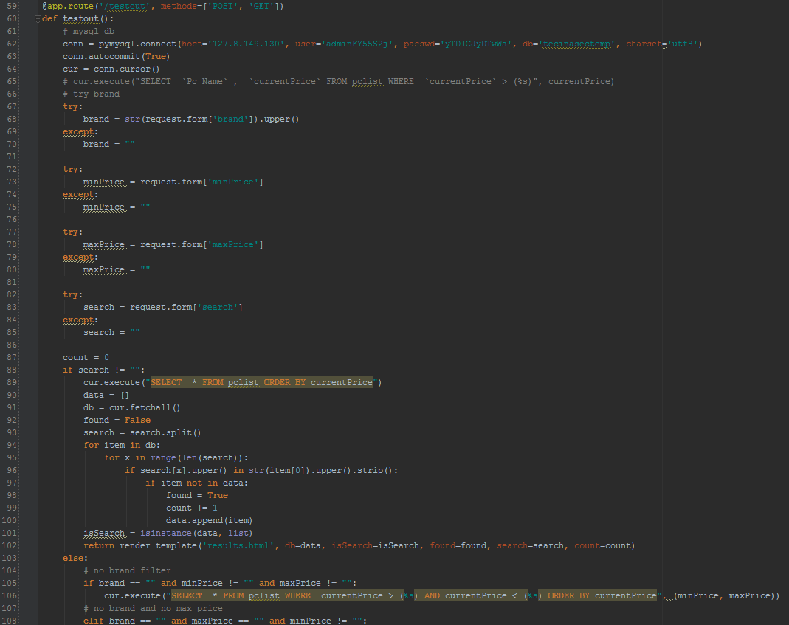

[5]

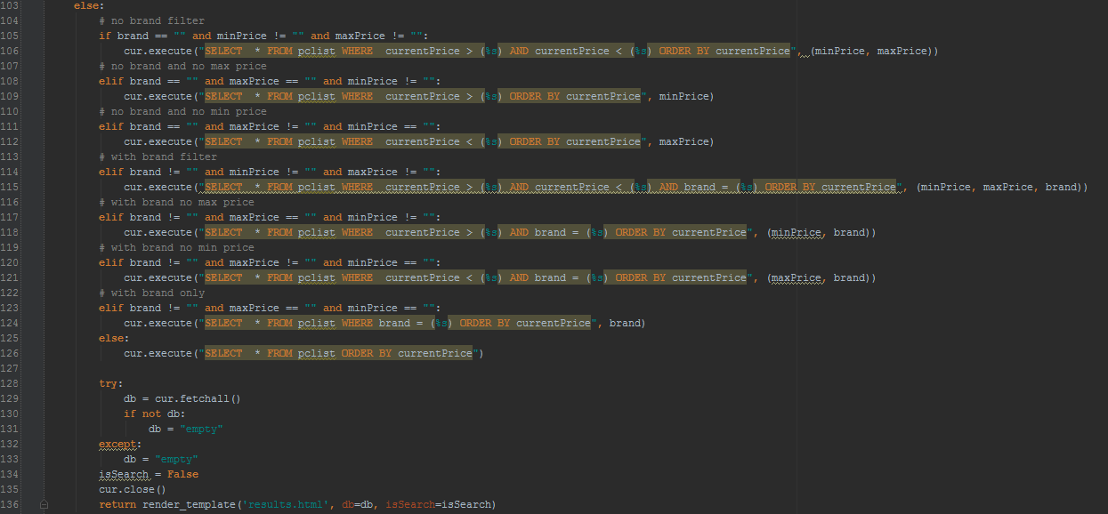

[6]

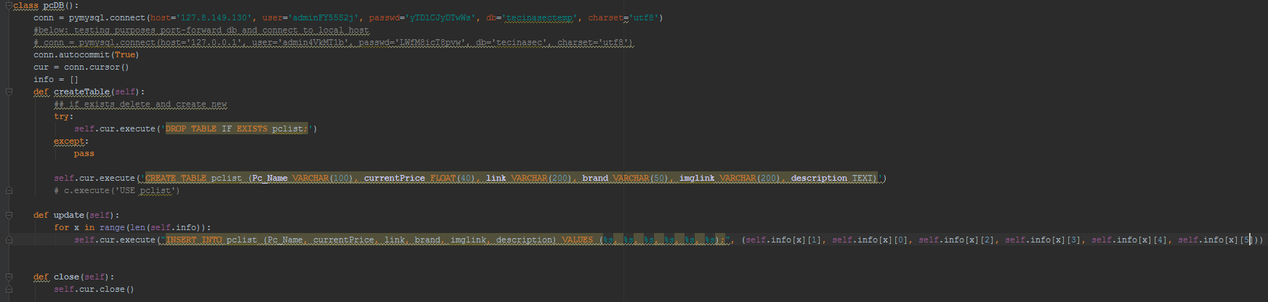

[7]

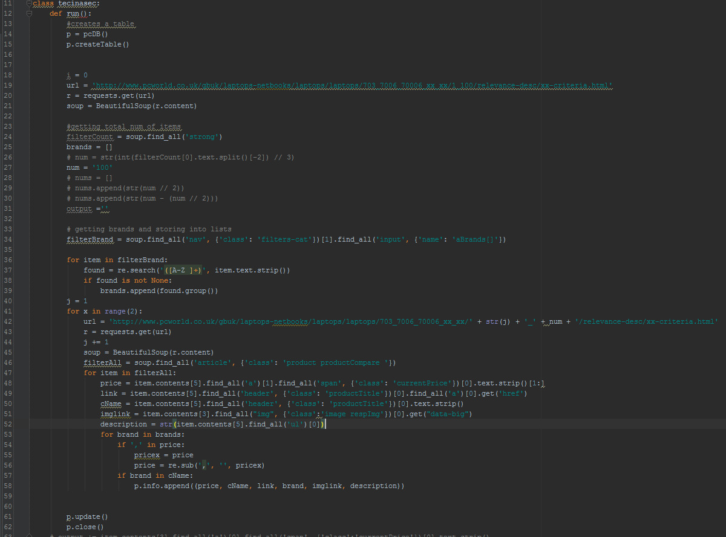

[8]

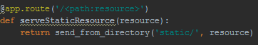

[9]

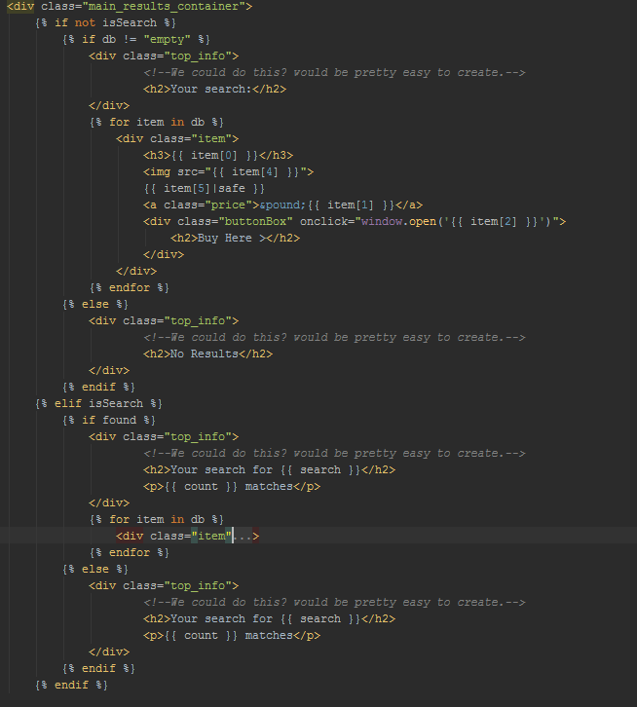

[10]

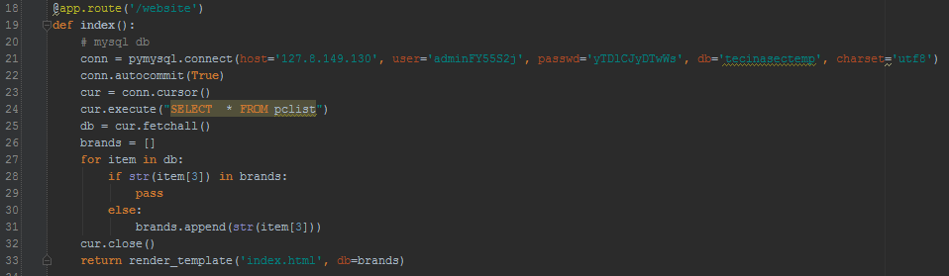

[11]



[12]

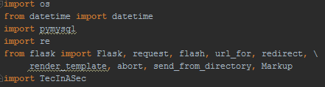

[13]

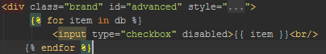

Laurynas

## B Team effort summary table

|  |  |  |  |  |  |  |  |  |  |  |  |
| --- | --- | --- | --- | --- | --- | --- | --- | --- | --- | --- | --- |
|  |  | **Meeting Attendance** | **Number of references added to the database** | **Number of précis added to the database** | **PowerPoint presentation given to team in week 19** | **Agendas in team logbook** | **Minutes in team logbook** | **Discussions added to the Team forum[2]** | **Product Development** | **Report Writing** |  |
| **Team Member** | **Role** | 0-10 | Rank order[3] | Rank order | 0 or 10 | 0-10 | 0-10 | Rank order | Rank order[4] | Rank order3 | TOTAL |
| Sean Traynor | **Leader** | 9 | 4 | 5 | 9.7 |  |  | 6 | 6 | 5 | 44,7 |
| Dale Carr | **Project Manager** | 7 | 2 | 3 | N/A | 10 | 10 | 2 | 5 | 2 | 41 |
| Laurynas Pupsta | **Specialist** | 9 | 6 | 5 | 9.5 |  |  | 4 | 6 | 3 | 42,5 |
| Charlie Hammond | **Specialist** | 9 | 6 | 6 | 9.5 |  |  | 6 | 6 | 6 | 48,5 |
| Valentinas Vaiceliunas | **Specialist** | 7 | 4 | 3 | 9.6 |  |  | 3 | 5 | 4 | 35,6 |

## C Project management Gantt chart (Split into two screenshots)

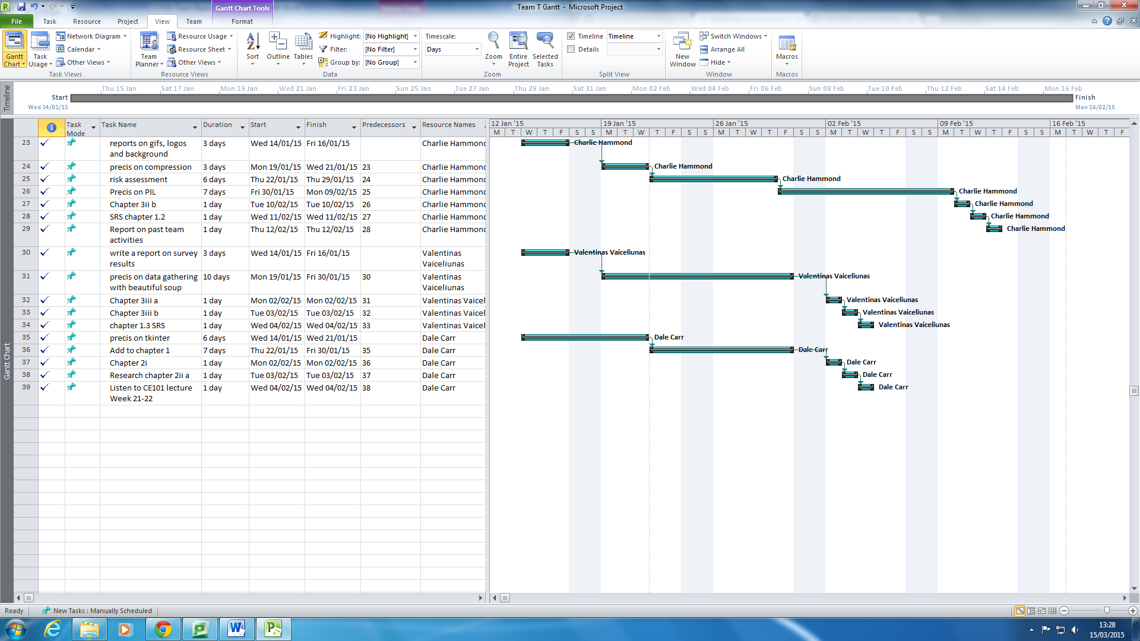

1. Gantt chart in Appendix C
2. Only include top-level posts, not replies.
3. For example for a team of 6 give 6 to the person with the highest number.
4. You can give the same rank order to more than one team member so if all have contributed equally then for a team of 6 score 6 for all.